**How to update MTA Web Services**

1. 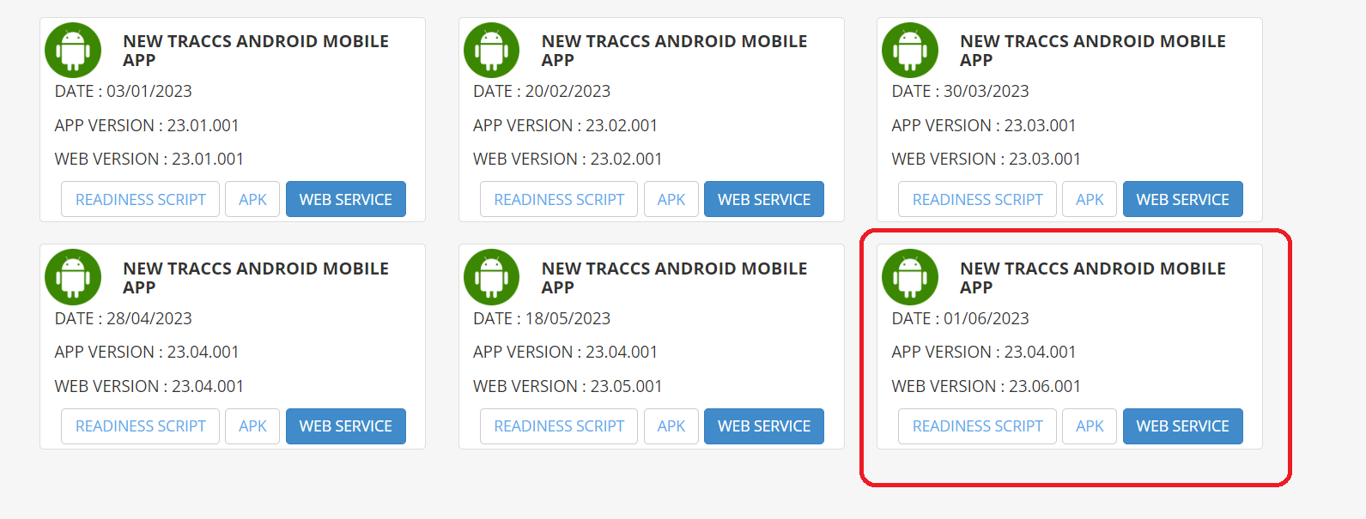Get latest source from adamas site, readiness Script from downloads using below site like: [www.adamas.net.au](http://www.adamas.net.au)
2. Extract source on IIS server
3. Open IIS server -> Open sites- 🡪 timesheet
4. 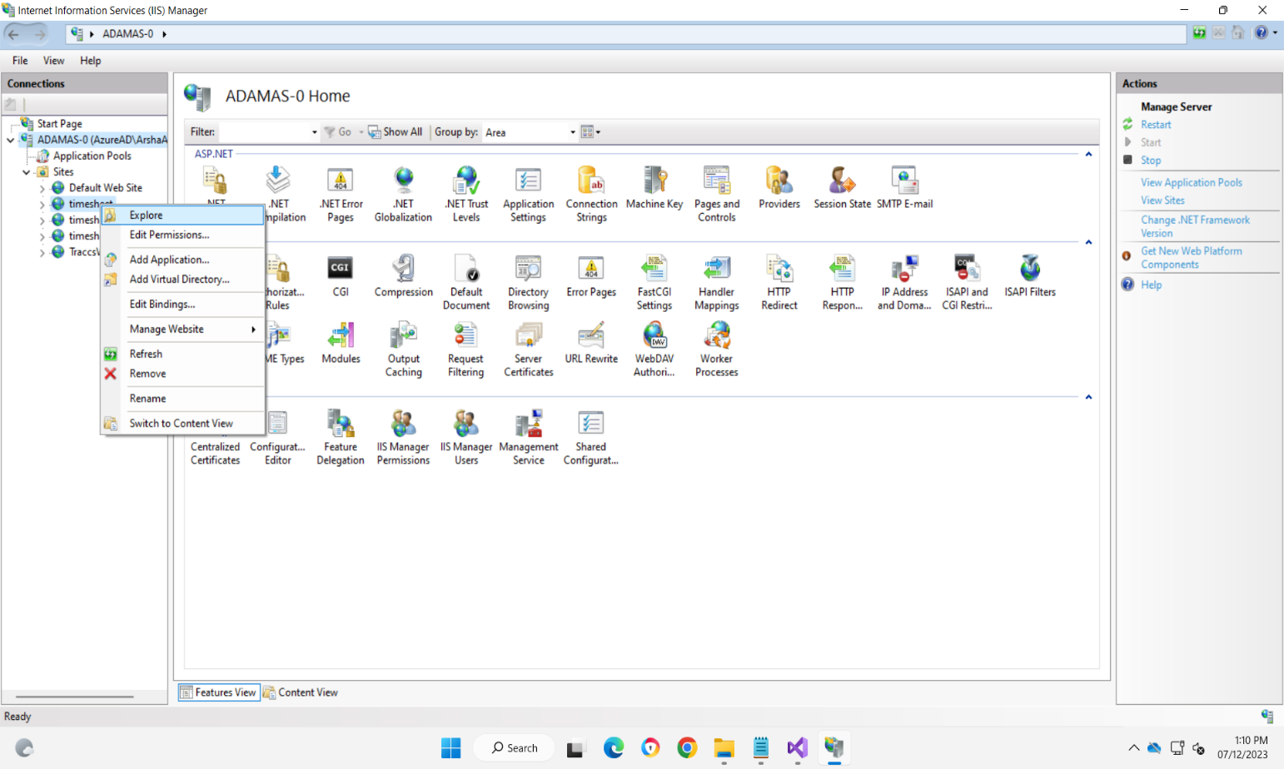Right Click on timesheet 🡪 Explore.
5. Copy web service Source and replace in server location of timesheet.

(C:\inetpub\wwwroot\timesheet)

1. Download readiness script from adamas site
2. 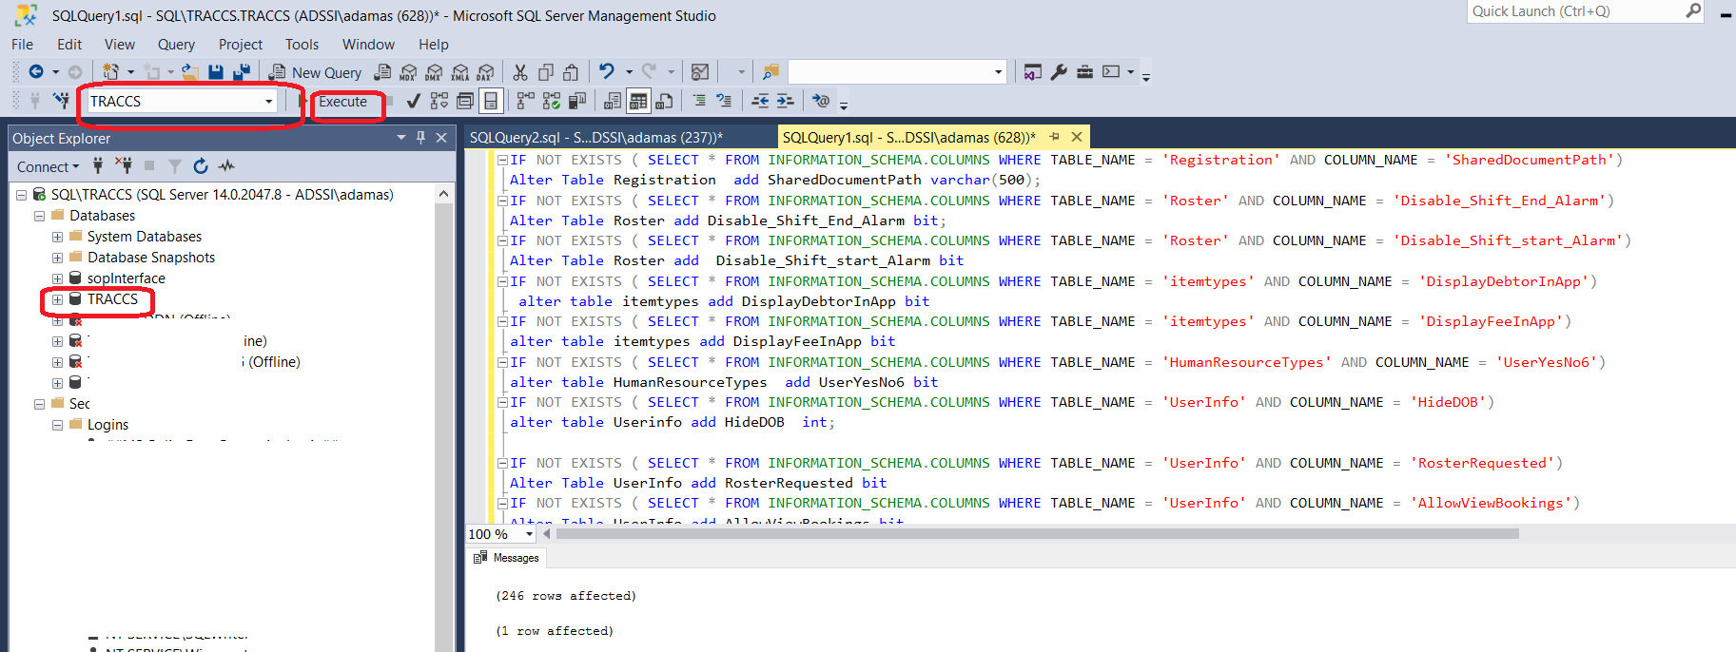Run readiness Script in SQL server query editor or Traccs Database Manager
3. While running Script in SQL server query editor, make it sure Traccs Database is selected.
4. If it shows any error, contact adamas support to get it fix